|  |  |
| --- | --- |
| Logo, company name  Description automatically generated–––– | FPT ACADEMY INTERNATIONAL  FPT – APTECH COMPUTER EDUCATION |

Centre Name: ACE-HCMC-2-FPT.

Address: 590 Cach Mang Thang 8, District 3, Ho Chi Minh City, Viet Nam.

**[Fantastic Yachts]**

|  |  |  |
| --- | --- | --- |
| Supervisor: | Phạm Thị Lánh | |
| Term: | 1 | |
| Batch No: | T1.2208.M0 | |
| Group No: | 1 | |
| Order: | Full name | Roll No. |
| 1. | Hồ Tuấn Kiệt | Student1405195 |
| 2. | Chiếm Nguyễn Nhật Trường | Student1405183 |
| 3. | Nguyễn Văn Thiện | Student1408856 |

Month 10 Year 2022

This is to certify that

**Mr. HỒ TUẤN KIỆT**

**Mr. CHIẾM NGUYỄN NHẬT TRƯỜNG**

**Ms. NGUYỄN VĂN THIỆN**

Have successfully Designed & Developed

**FANTASTIC YACHTS**

Submitted by: **Ms. PHAM THI LANH**

Date Of Issue: October, 2022

Authorized Signature:

# Content

Contents

Content 3

Acknowledge 4

Synopsis 5

REVIEW 1 6

Problem Definition 7

Customer Requirements Specifications 8

Architecture and Design of the project 9

Site map 10

Website Design 11

I. Homepage 12

II. Sign in 15

III. Sign up 16

IV. Sales 17

V. Contact 16

VI.Product Detail……………………………………………………………………………………………………………..18

Task Sheet 19

REVIEW 2 20

WEBSITE USER INTERFACE 22

I. Homepage 22

II. Sign in 25

III. Sign up 26

IV. Product Category/Search Page 26

V. Product Detail 28

VI. Request call………………………………………………………………………………………………………………….29

VII. Contact 30

VIII. About 30

Task Sheet 31

Testing document 32

Final checklist 33

# Acknowledge

As we understand that the eProject is a step-by-step learning environment that closely simulates the classroom and Lab based learning environment into actual implementation. It is a project implementation at your fingertips!! An electronic, live juncture on the machine that allows you to.

✓ Practice step by step i.e., laddered approach.

✓ Build a larger, more robust application.

✓ Usage of certain utilities in applications designed by the user.

✓ Single program to unified code leading to a complete application.

✓ Learn implementation of concepts in a phased manner.

✓ Enhance skills and add value.

✓ Work on real life projects.

✓ Give a real-life scenario and help to create applications more complicated and useful.

✓ Mentoring through email support.

We would like to send a great thank to our professor and others student for the adorable support during the time in the project.

Beside several mistakes we had made in the project, we hope to have more opportunities to widen our knowledge in the web developing world.

We also thank you so much for your information and the “demo” project from India APTECH to help us get more reality experience in this project. Since we have gained more experience from this project, we will not stop learning anything as much as we can to be more successful in the future.

Your Sincerely,

Team Group 01.

# Synopsis

- The Objective of this program we aim is to give a sample project to work on real life projects. These applications help us build a larger, more robust application.

- The objective is not to teach us HTML/JavaScript but to provide us with a real life scenario and help us create basic applications using the tools.

- Hence, we can revise the chapters before we start with the project.

- This project The Objective of this program is to give a sample project to work on real life projects. These applications help you build a larger, more robust application.

- The objective is not to teach you the software but to provide you with a real-life scenario and help you create basic applications using the tools.

- You can revise the topics before you start with the project.

- This project is meant for students who have completed the module of HTML5.

- These programs should be done in the Lab sessions with assistance of the faculty if required.

- The website (in this project) is a tool that help the company to access the

international market and gain more and more new customers.

- It is very essential that a student has a clear understanding of the subject.

# 

# REVIEW 1

## Problem Definition

Fantastic Yachts is a global database of all existing models of sailing and motor yachts and a web service which helps search, choose, compare and buy boats. itBoat partners with experienced and trusted yacht sellers and connects buyers with sellers through [FantasticYachts Catalog](https://itboat.com/en/catalog) to ensure the most seamless buying experience.

Fantastic Yachts is also a [web magazine](https://itboat.com/en/journal/articles) about boats, yachts and yacht life. We have been delivering objective information about yachts and boats since our inception in 2020.

We can confidently recommend and choose the company that :

1. Has an official status and is verified by the shipyard
2. Has extensive experience in transactions with yachts of your chosen type
3. Is verified by us for professionalism and honesty
4. Is close to you and speaks the same language as you
5. Sells boats at the official prices of the shipyard, without “cheating”, and will even help knock out an additional discount from the shipyard, which is difficult to get “off the street”
6. Will, in general, save you a lot of time and nerves

Thus, you will receive a yacht at absolutely the same price you’d get if you directly communicated with the manufacturer. But since you have an independent professional assistant at your side, you will get a better product, without unnecessary imposed options and with more careful control over the fulfillment of obligations by the shipyard. And the whole process of ordering and building will be easier, faster and more relaxed.or email address. Moreover, many customers want to come to the store to view the product and then decide whether to buy it or not.

## Customer Requirements Specifications

|  |
| --- |
| USER: |
| Input:  ● Input consumer’s address of residence or office  ● Send questions/requests to the company |
| Process:  ● Process consumer’s address data  ● Collect questions/requests sent by consumers |
| Output:  ● Show the store address to consumers  ● Reply to the consumer’s requests/questions |

|  |
| --- |
| WEBMASTER: |
| Input:  ● Control website database, input product information,… |
| Process:  ● Analyse website |
| Output:  ● Website interface, images, forms, …  ● Giving interaction |

|  |
| --- |
| HARDWARE / SOFTWARE REQUIREMENT: |
| Software:  ● Notepad/HTML editor  ● Dreamweaver/Javascript |
| Hardware:  ● A minimum computer system that will help you access all the tools in the courses is a Pentium 166 or better  ● 64 Megabytes of RAM or better |

## Architecture and Design of the project



## Site map

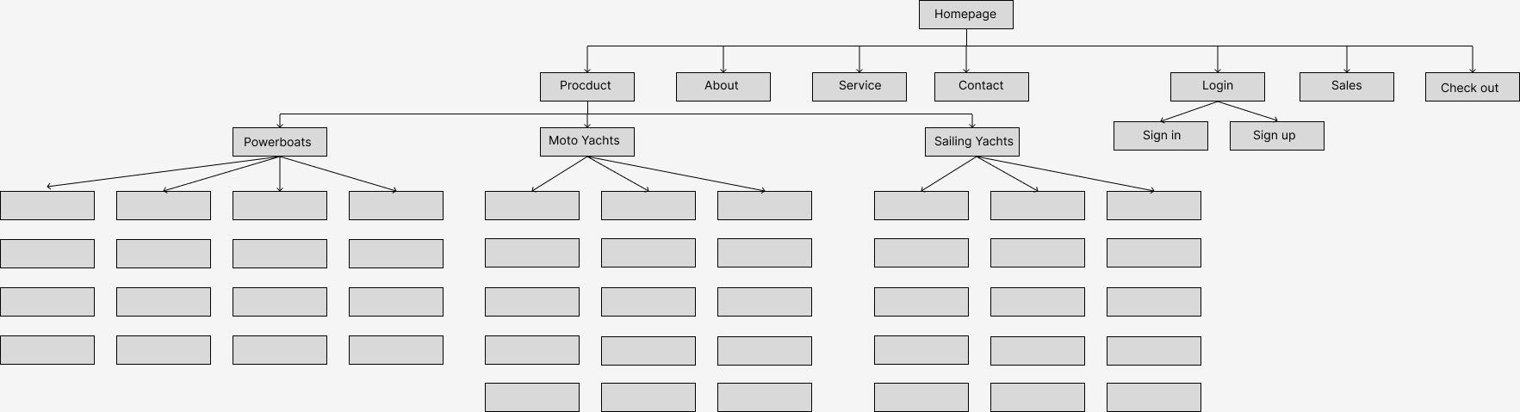

## Website Design

### Homepage

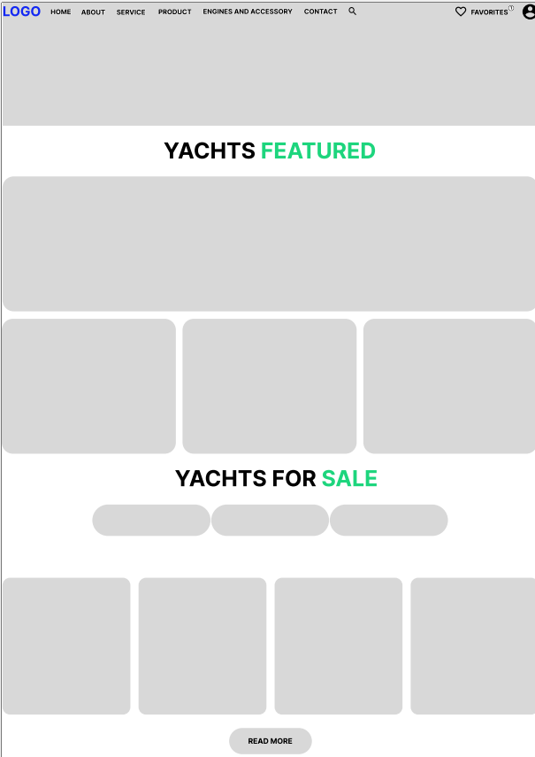

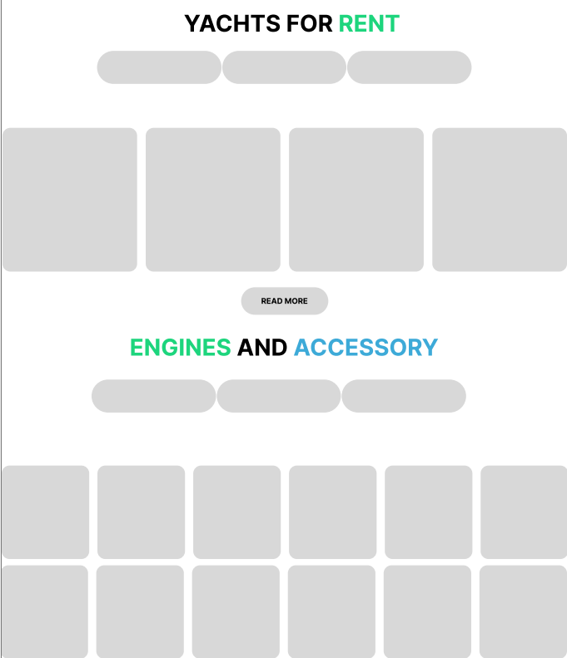

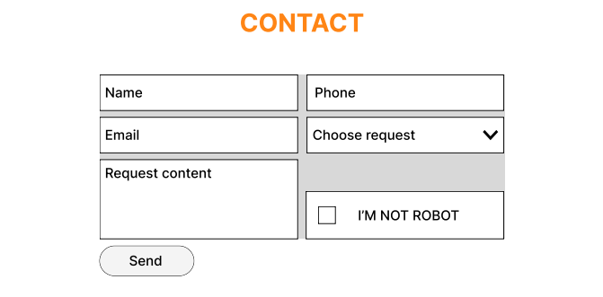

**Description:** This is a homepage , the top of this page is a header, after that is a navigation bar. The main part of a homepage beside the slider also includes 5 sections: yachts featured, yachts for sale, yachts for rent, engines and accessory and contact. And the footer will be placed after the contact.

### Sign in

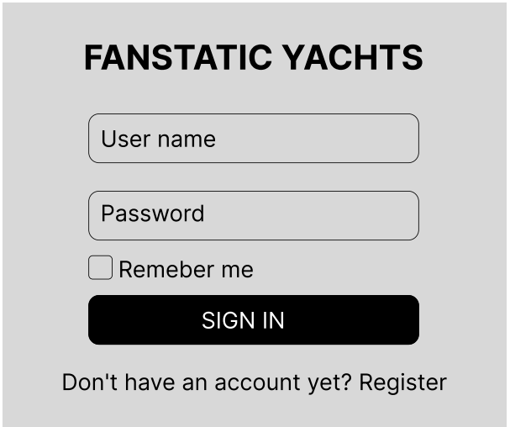

**Description:** When the user clicks on the human icon in the header, it leads to a sign in page. This form requires the user to enter an email address and a password. After clicking the login button, the user will be redirected to the homepage.

### Sign up

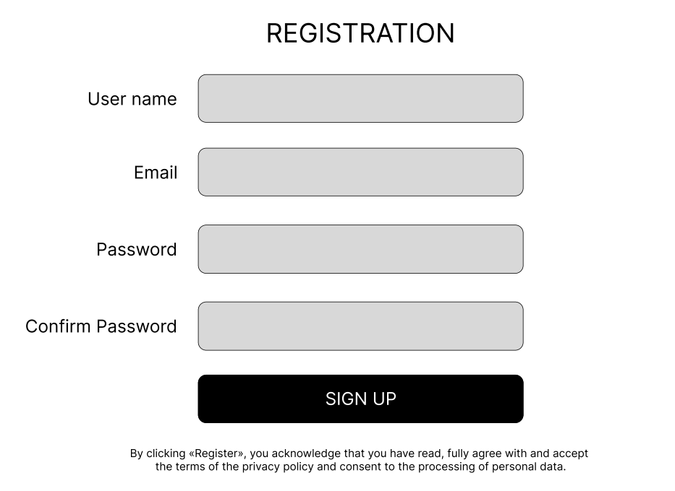

**Description:** If the user hasn’t created an account, he/she can click to Create new account in the sign in page and it will lead to this sign up page. This sign up form requires the user to enter 4 fields: user name, email, password and confirm. After clicking the sign up button the user will be redirected to the homepage.

### Sales

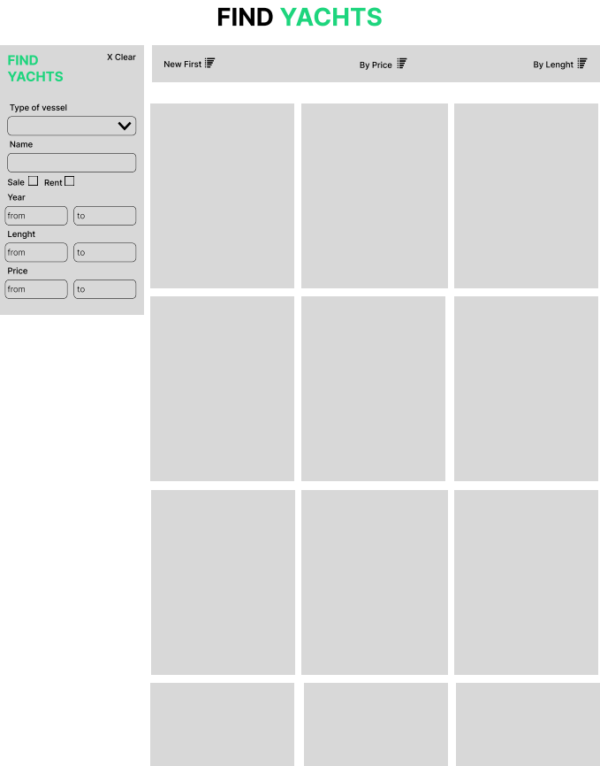

**Description:** When the user clicks on the Sales tag in navigation, it will lead to this page. On this sales page we can search by price, latest product, or find the appropriate lea

### Contact

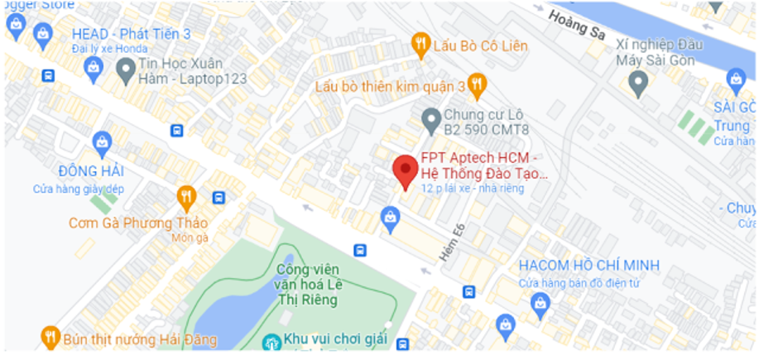

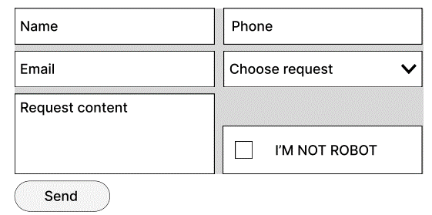

**Description:** After clicking the Contact tag on the navigation bar, the user will be redirected to this page. The first part of this page is a map, the last part of this page is a Send information form to send their information to fanpage.

### VI.Product Detail

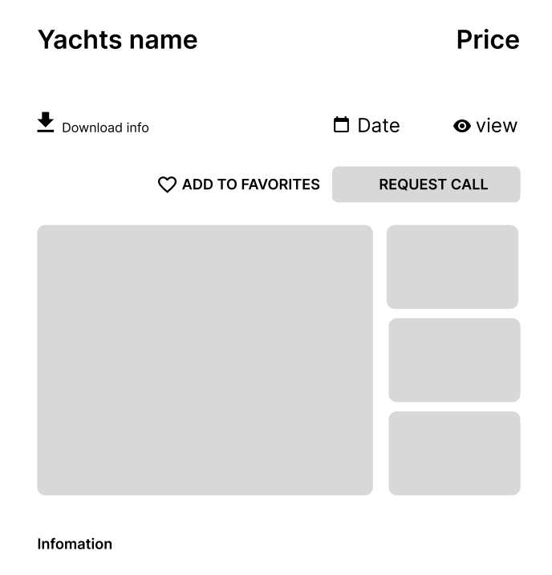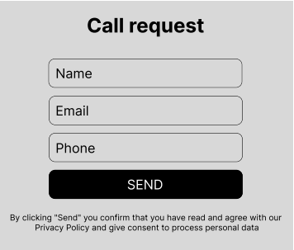

**Description:** When the user clicks on a specific product it will lead to this product detail page. Beside in detail information about the product. Below is to send us contact information.

## Task Sheet

|  |  |  |  |  |  |  |
| --- | --- | --- | --- | --- | --- | --- |
| **Project Ref No.** | **Project Title – Ask Me Mobile** | **Activity Plan Prepared by** | **Date of preparation of Activity Plan** | | | |
| **Task** | **Actual Start Date** | **Actual Days** | **Teammate Names** | **Status** |
| Brainstorming ideas for layouts and Project Object | | Kiệt | 29/10/2022 | 1 day | Kiệt | Completed |
| Draw site maps and architecture design | | Trường | 29/10/2022 | 1 day | Trường | Completed |
| Wire framing general page layout | | Kiệt | 29/10/2022 | 1 day | Kiệt | Completed |
| Collect static assets (pictures, mp4, documentation,…) | | Trường, Thiện | 29/10/2022 | 3 days | Trường,  Thiện | Completed |

# 

# REVIEW 2

# WEBSITE USER INTERFACE

### Homepage

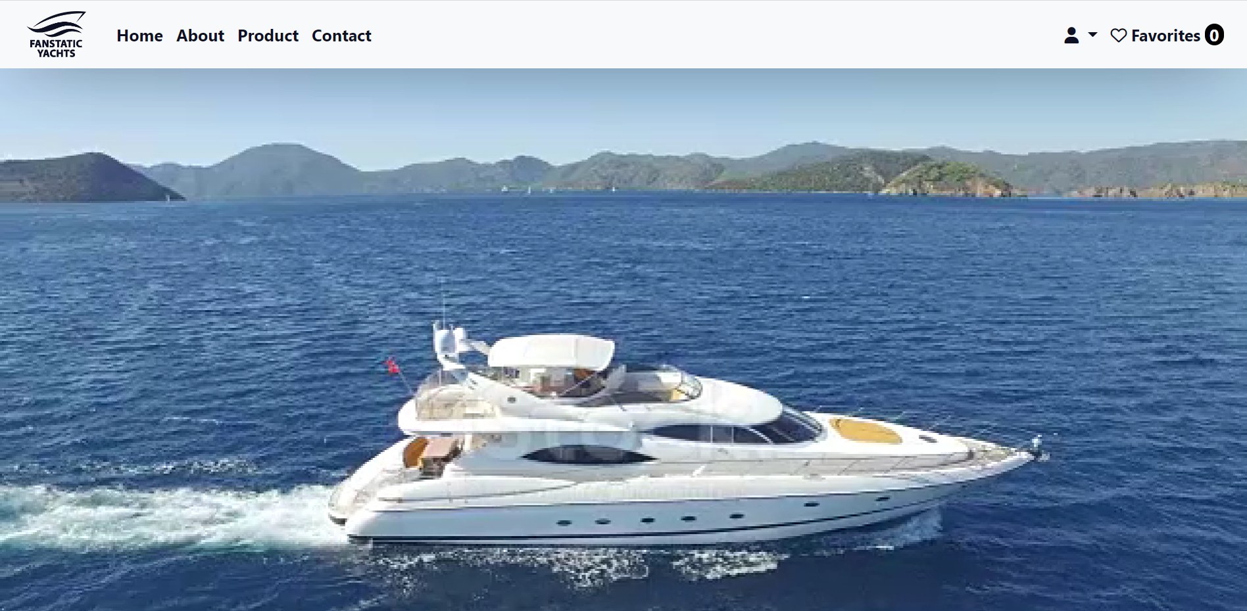

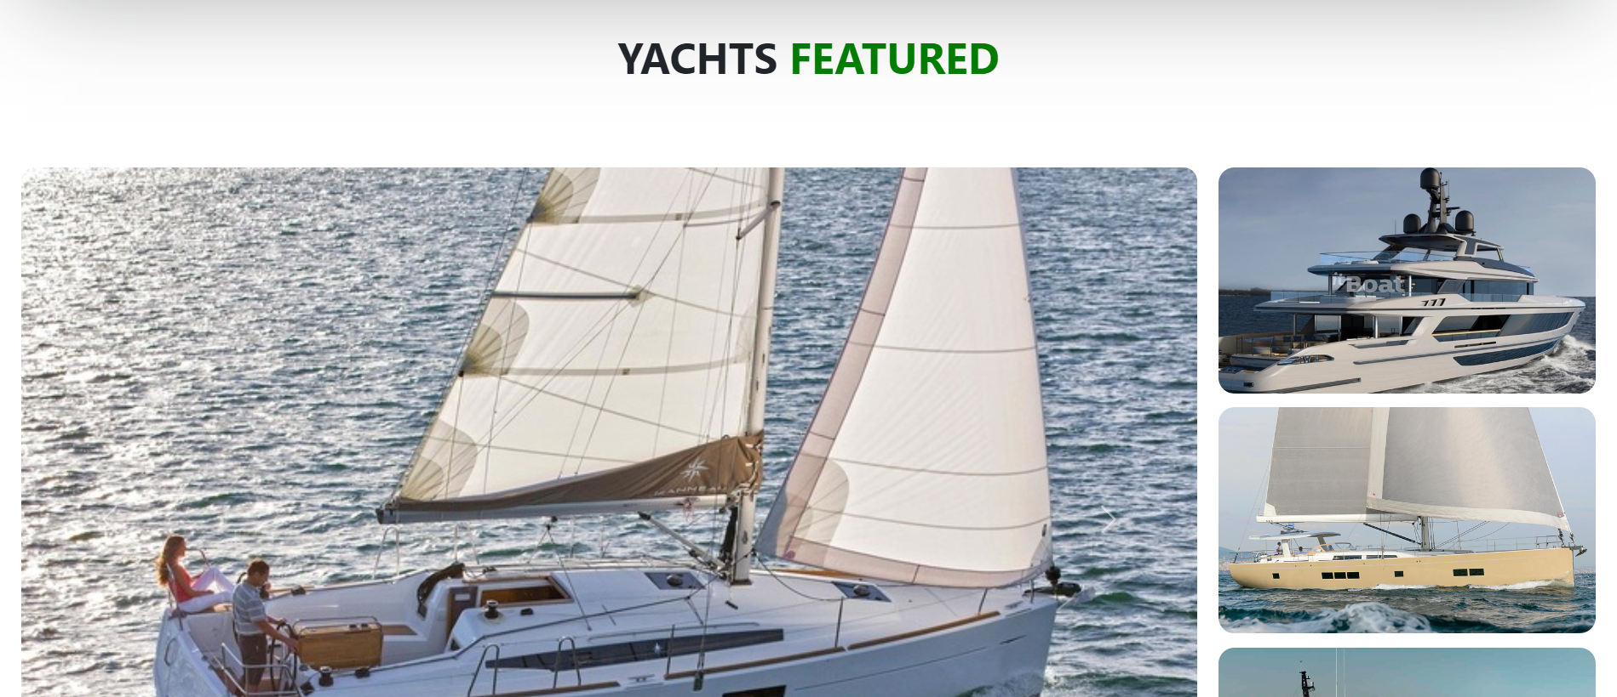 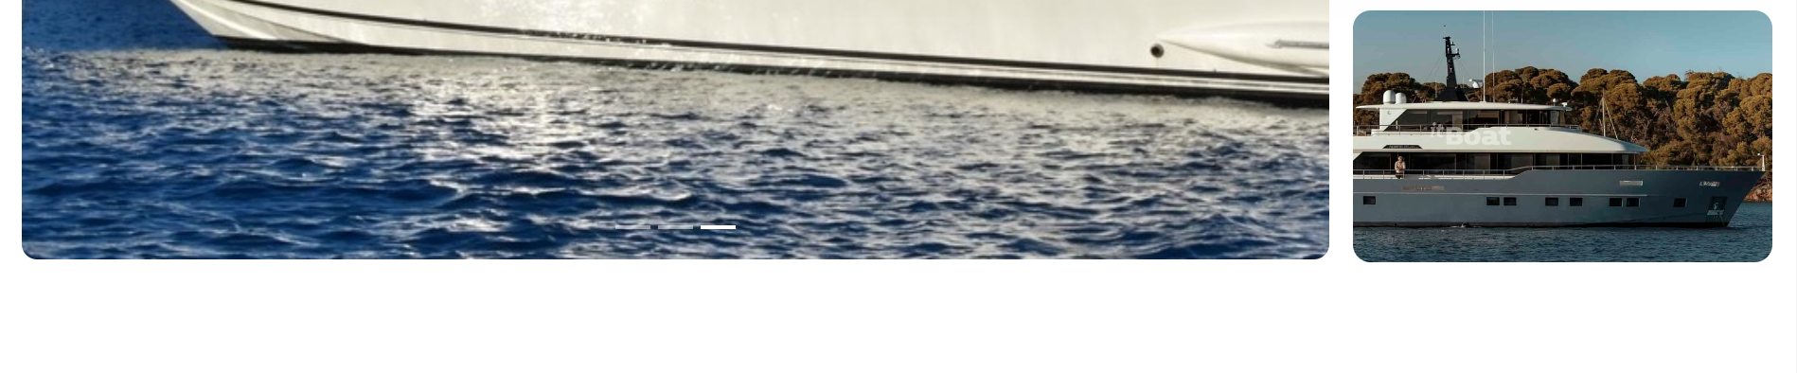 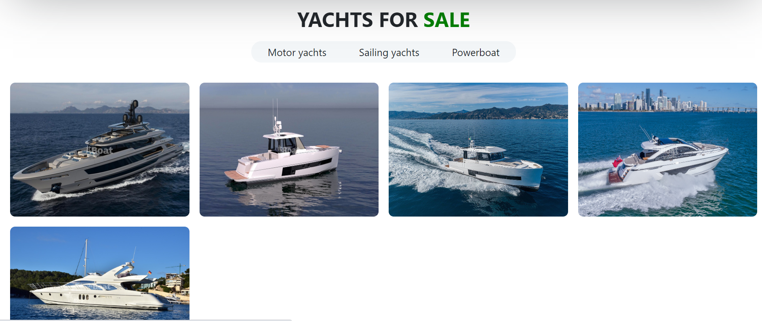  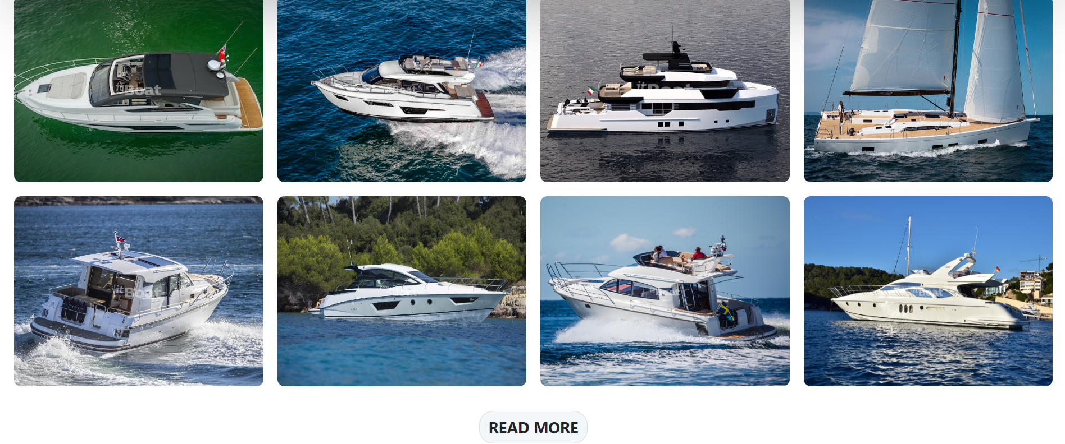 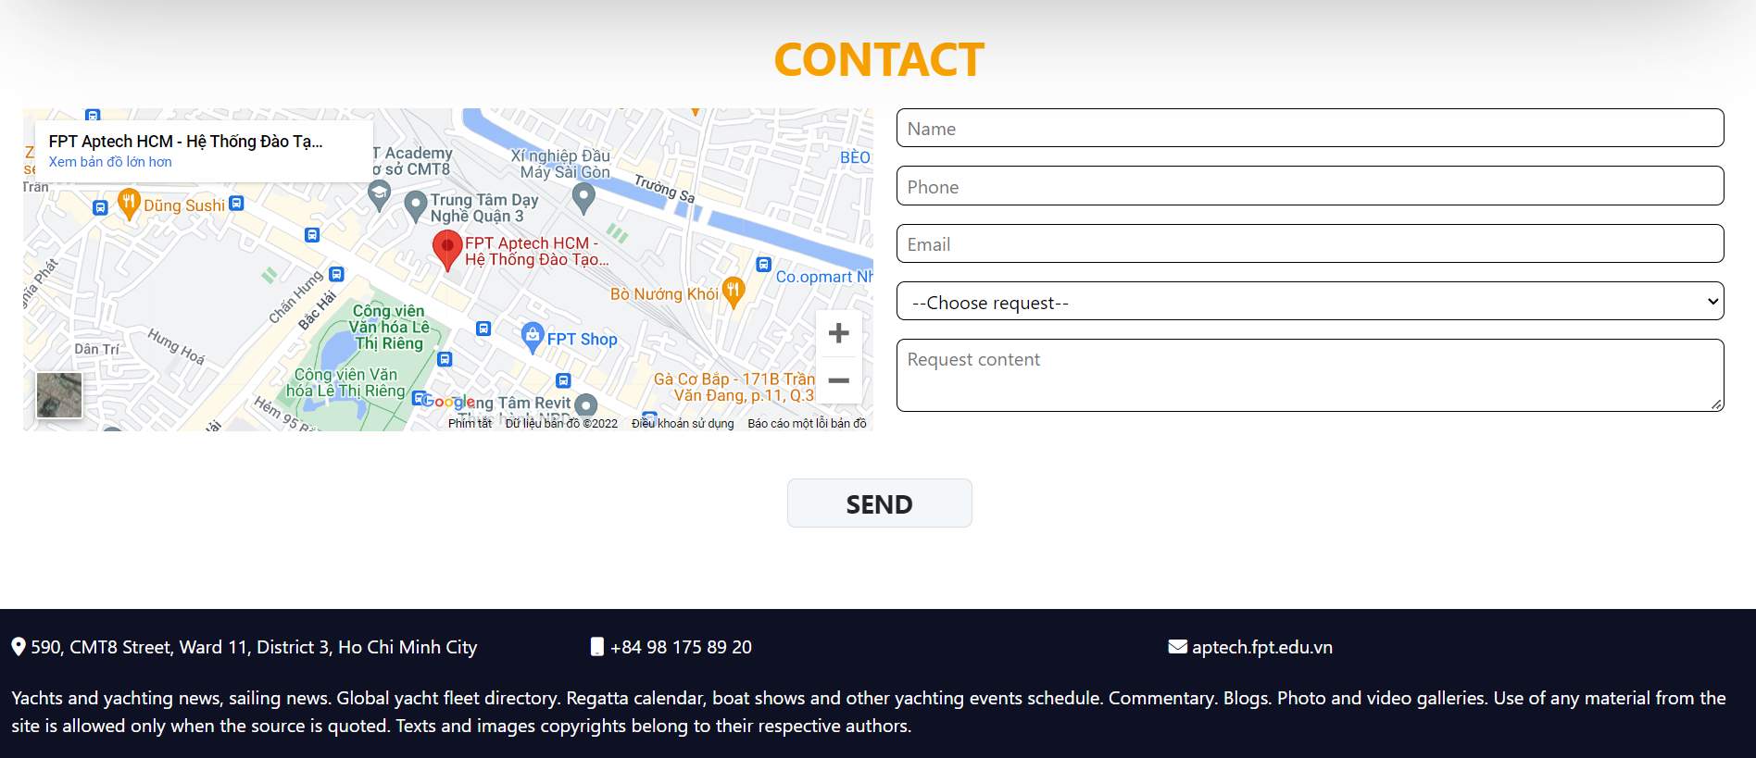

### Sign in

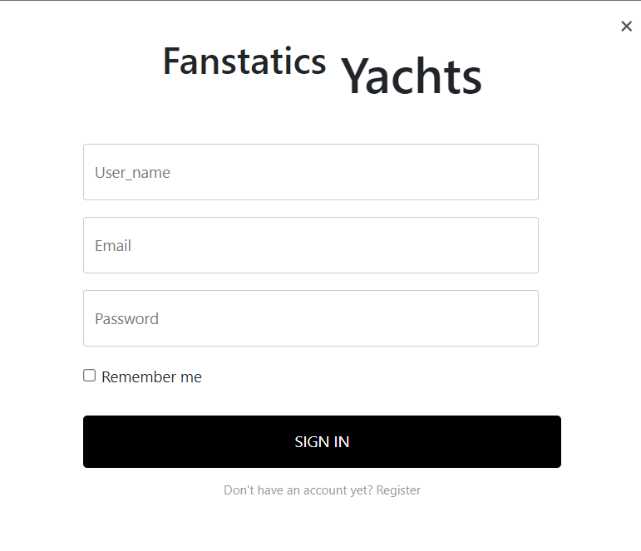

### Sign up

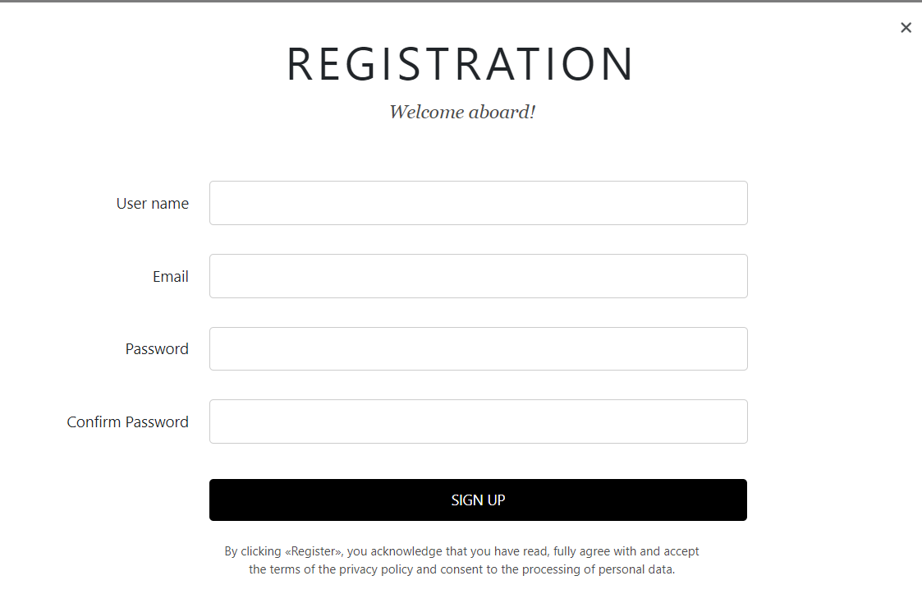

### Product Category/Search Page

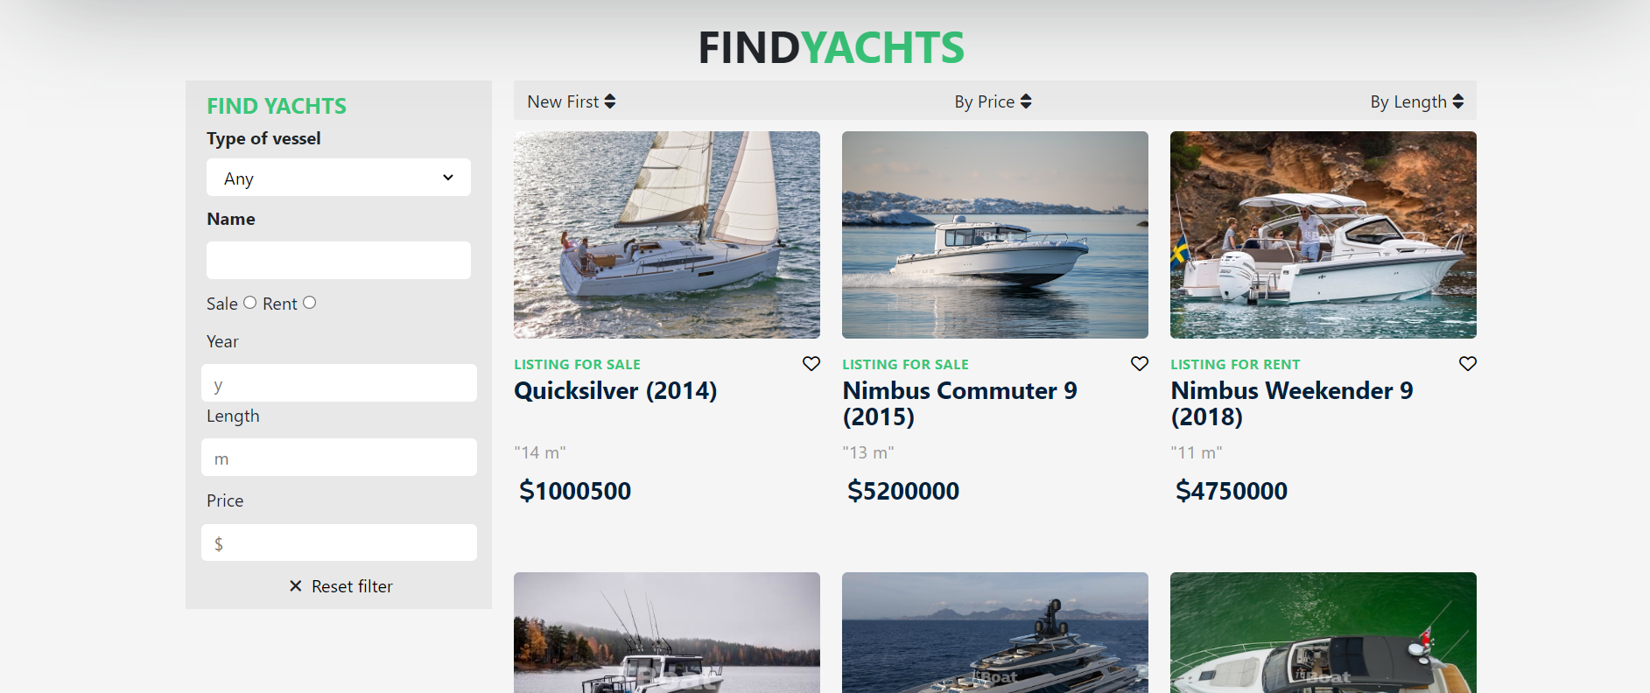

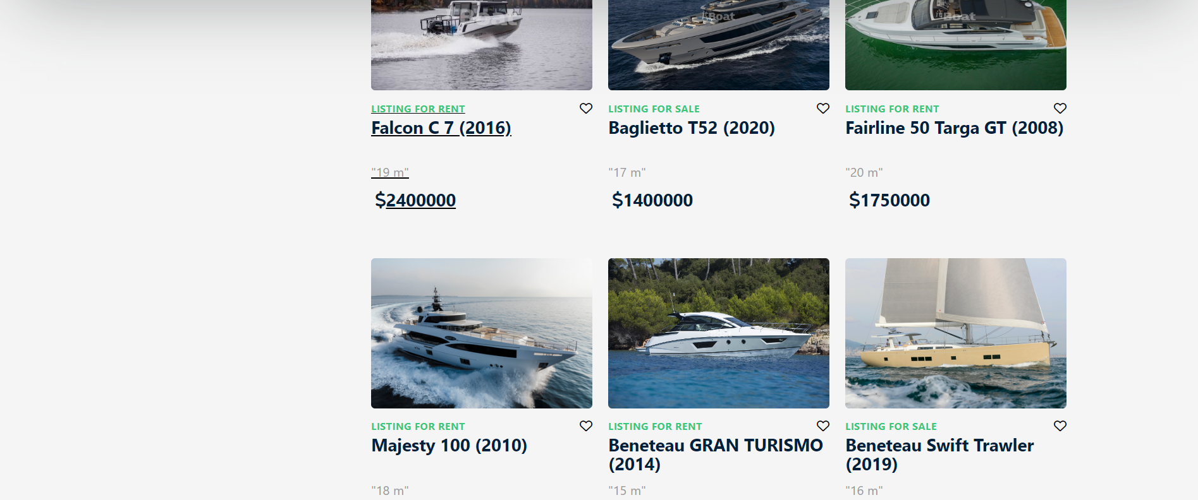 

### Product Detail

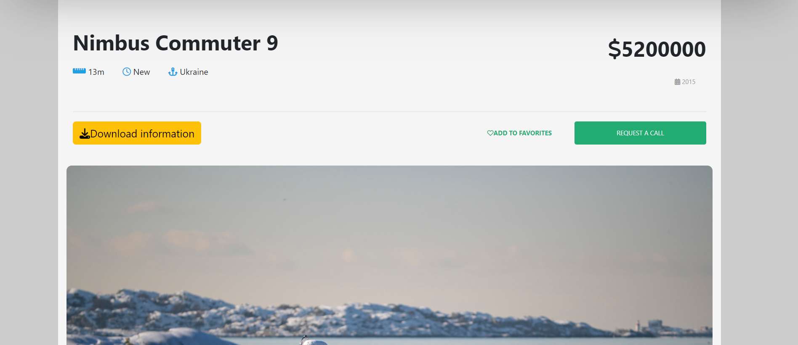 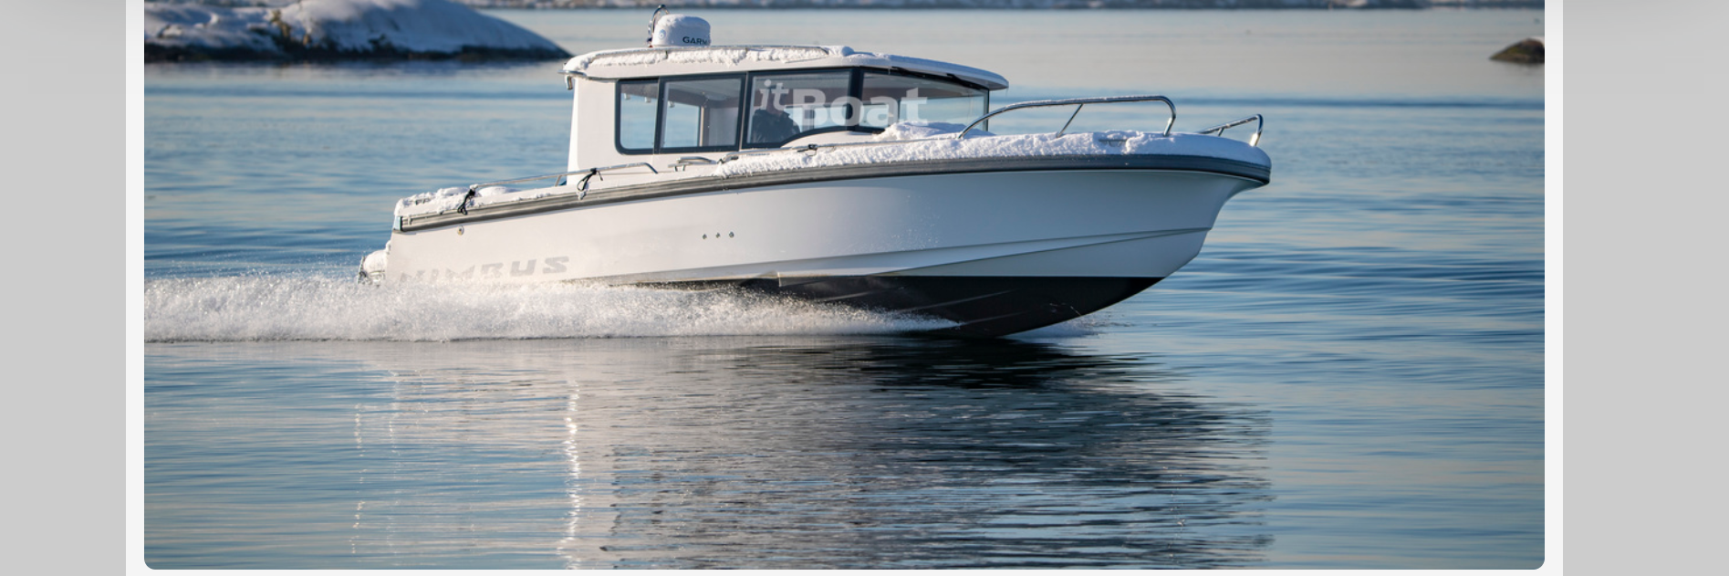 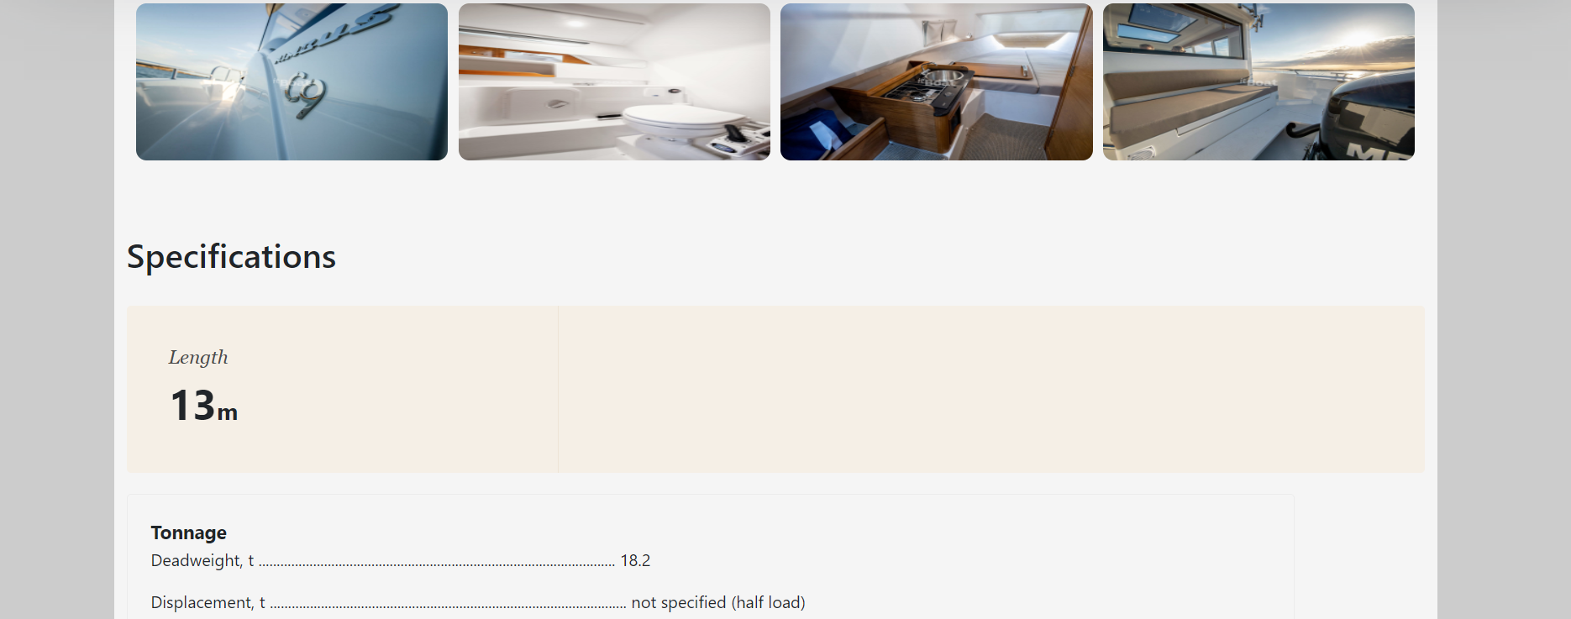

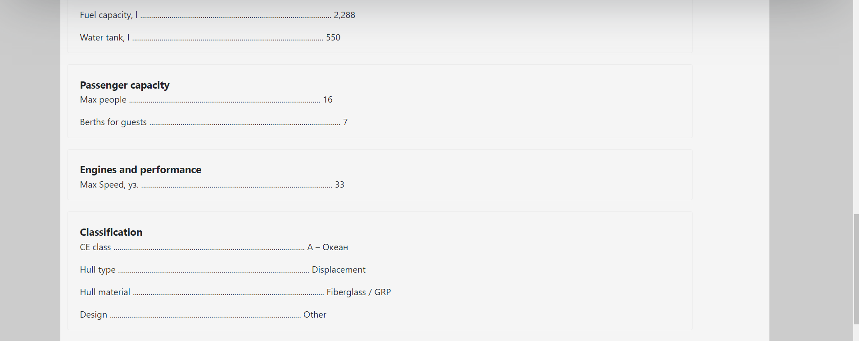

### Request call

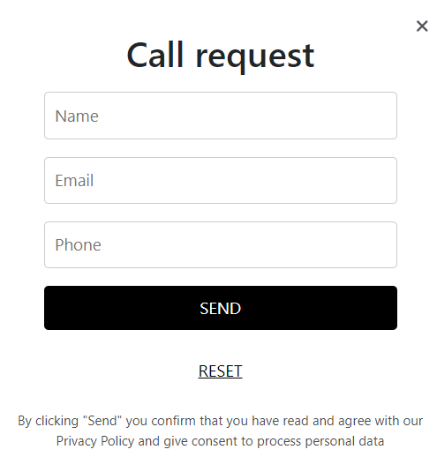

### Contact

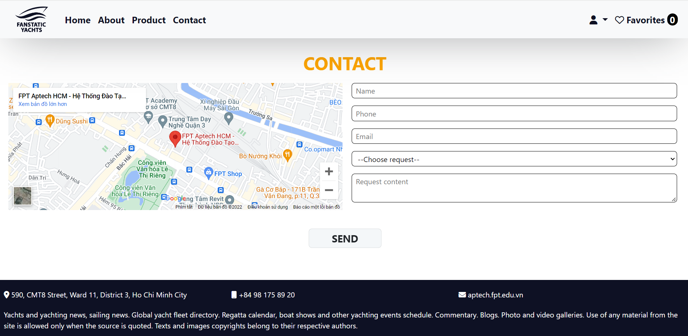

### About

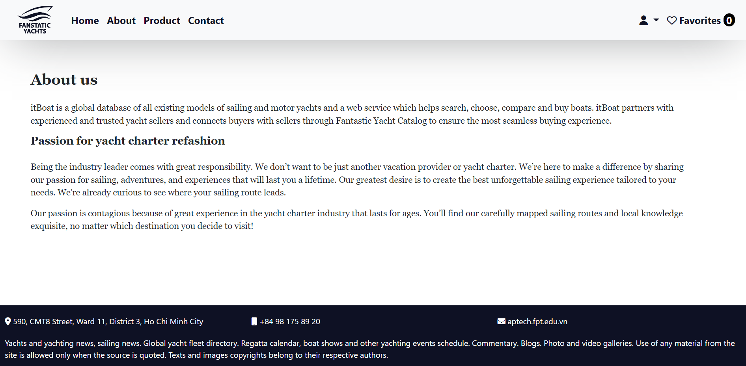

## Task Sheet

|  |  |  |  |  |  |  |
| --- | --- | --- | --- | --- | --- | --- |
| **Project Ref No.** | **Project Title – Ask Me Mobile** | **Activity Plan Prepared by** | **Date of preparation of Activity Plan** | | | |
| **Task** | **Actual Start Date** | **Actual Days** | **Teammate Names** | **Status** |
| Brainstorming ideas for layouts and Project Object | | Kiệt | 29/10/2022 | 1 days | Kiệt | Completed |
| Draw site maps and architecture design | | Trường | 29/10/2022 | 1 days | Trường | Completed |
| Wire framing general page layout | | Kiệt | 29/10/2022 | 3 days | Kiệt | Completed |
| Collect static assets (pictures, mp4, documentation,…) | | Trường,  Kiệt, | 29/10/2022 | 5 days | Trường,  Kiệt, | Completed |
| Design & Build Homepage | | Kiệt | 30/10/2022 | 8 days | Kiệt | Completed |
| Design & Build Sign in | | Thiện | 31/10/2022 | 7 days | Thiện | Completed |
| Design & Build Sign up | | Thiện | 31/10/2022 | 7 days | Thiện | Completed |
| Design & Build Product Category/Search Page | | Trường | 31/10/2022 | 5 days | Trường | Completed |
| Design & Build Product Detail | | Thiện | 7/11/2022 | 4 days | Thiện | Completed |
| Design & Build Contact | | Kiệt,  Thiện | 15/10/2022 | 5 days | Kiệt,  Thiện | Completed |
| Design & Build About | | Trường | 19/10/2022 | 3 days | Trường | Completed |
| Write Project Report | | Trường,  Thiện | 22/10/2022 | 1 days | Trường,  Thiện | Completed |

## Testing document

|  |  |  |  |  |
| --- | --- | --- | --- | --- |
| **Sr.No** | **Features Tested** | | | **Remarks** |
| 1 | Have all the views, modules and controllers been | |  | OK |
| properly integrated and is the site function as a single | | |
| page application? | |  |
| 2 | Are the GUI content devoid of spelling mistakes? | | | OK |
| 3 | Is the application user-friendly? | | | OK |
| 4 | Is the Website launching correctly in all popular | |  | OK |
| browsers? |  |  |
| 5 | Are all the forms validated with proper criteria? | | | OK |
| 6 | Do all text links lead to the appropriate website? | | | OK |
| 7 | Do all image links lead to the appropriate website? | | | OK |
| 8 | Are all the images and links clearly visible on the page? | | | OK |
| 9 | Does the Web page work properly in all the tested | |  | OK |
| browsers? |  |  |
| 10 | Does the Web page take too long to be loaded fully? | | | OK |
| 11 | Is the navigation sequences correct through all the Web | | | OK |
| pages on the site? | |  |
| 12 | Is the JavaScript code working as expected in all click | | | OK |

## Final checklist

|  |  |  |  |  |
| --- | --- | --- | --- | --- |
| **Sr.No** | **Features Tested** | | | **Remarks** |
| 1 | Have all the views, modules and controllers been | |  | OK |
| properly integrated and is the site function as a single | | |
| page application? | |  |
| 2 | Are the GUI content devoid of spelling mistakes? | | | OK |
| 3 | Is the application user-friendly? | | | OK |
| 4 | Is the Website launching correctly in all popular | |  | OK |
| browsers? |  |  |
| 5 | Are all the forms validated with proper criteria? | | | OK |
| 6 | Do all text links lead to the appropriate website? | | | OK |
| 7 | Do all image links lead to the appropriate website? | | | OK |
| 8 | Are all the images and links clearly visible on the page? | | | OK |
| 9 | Does the Web page work properly in all the tested | |  | OK |
| browsers? |  |  |
| 10 | Does the Web page take too long to be loaded fully? | | | OK |
| 11 | Is the navigation sequences correct through all the Web | | | OK |
| pages on the site? | |  |
| 12 | Is the JavaScript code working as expected in all click | | | OK |